**Module 2 (Junction theory)**

**P-N JUNCTION**

When a p-type semiconductor is suitably joined to n-type semiconductor, the contact surface is called pn junction. Most semiconductor devices contain one or more pn junctions. The pn junction is of great importance because it is in effect, the control element for semiconductor devices.

**Formation of pn junction**.: In actual practice, the characteristic properties of pn junction will not be apparent if a p-type block is just brought in contact with n-type block. In fact, pn junction is fabricated by special techniques like alloying, solid state diffusion method etc.

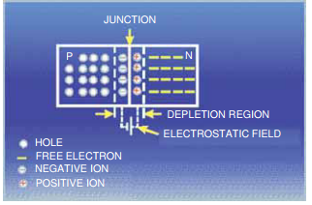

**Properties of pn Junction:**

At the instant of pn-junction formation, the free electrons near the junction in the n region begin to diffuse across the junction into the p region where they combine with holes near the junction. The result is that n region loses free electrons as they diffuse into the junction. This creates a layer of positive charges (pentavalent ions) near the junction. As the electrons move across the junction, the p region loses holes as the electrons and holes combine. The result is that there is a layer of negative charges (trivalent ions) near the junction. These two layers of positive and negative charges form the depletion region (or depletion layer). The term depletion is due to the fact that near the junction, the region is depleted (i.e. emptied) of charge carries (free electrons and holes) due to diffusion across the junction. It may be noted that depletion layer is formed very quickly and is very thin compared to the n region and the p region. For clarity, the width of the depletion layer is shown exaggerated.

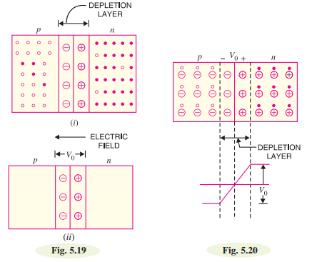

Once pn junction is formed and depletion layer created the diffusion of free electrons stops. In other words, the depletion region acts as a barrier to the further movement of free electrons across the junction. The positive and negative charges set up an electric field. This is shown by a black arrow in Fig. 5.19 (i). The electric field is a barrier to the free electrons in the n-region. There exists a potential difference across the depletion layer and is called barrier potential (V0). The barrier potential of a pn junction depends upon several factors including the type of semiconductor material, the amount of doping and temperature.

The typical barrier potential is approximately: For silicon, V0 = 0.7 V ; For germanium, V0 = 0.3 V Fig. 5.20 shows the potential (V0 ) distribution curve.

**Applying D.C. Voltage Across pn Junction or Biasing a pn Junction:**

In pn junction, there are following two bias conditions:

1. Forward biasing 2. Reverse biasing

**1. Forward biasing**: When external d.c. voltage applied to the junction is in such a direction that it cancels the potential barrier, thus permitting current flow, it is called forward biasing. To apply forward bias, connect positive terminal of the battery to p-type and negative terminal to n-type as shown in Fig. 5.21. The applied forward potential establishes an electric field which acts against the field due to potential barrier. Therefore, the resultant field is weakened and the barrier height is reduced at the junction as shown in Fig. 5.21. As potential barrier voltage is very small (0.1 to 0.3 V), therefore, a small forward voltage is sufficient to completely eliminate the barrier. Once the potential barrier is eliminated by the forward voltage, junction resistance becomes almost zero and a low resistance path is established for the entire circuit. Therefore, current flows in the circuit. This is called forward current. With forward bias to pn junction, the following points are worth noting:

(i) The potential barrier is reduced and at some forward voltage (0.1 to 0.3 V), it is eliminated altogether.

(ii) The junction offers low resistance (called forward resistance, Rf ) to current flow.

(iii) Current flows in the circuit due to the establishment of low resistance path. The magnitude of current depends upon the applied forward voltage.

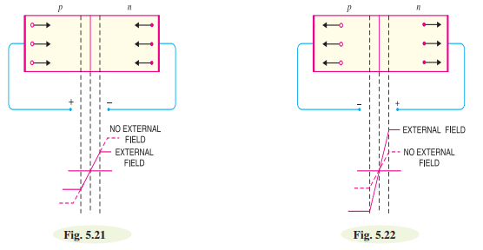

**2. Reverse biasing**: When the external d.c. voltage applied to the junction is in such a direction that potential barrier is increased, it is called reverse biasing. To apply reverse bias, connect negative terminal of the battery to p-type and positive terminal to n-type as shown in Fig. 5.22. It is clear that applied reverse voltage establishes an electric field which acts in the same direction as the field due to potential barrier. Therefore, the resultant field at the junction is strengthened and the barrier height is increased as shown in Fig. 5.22. The increased potential barrier prevents the flow of charge carriers across the junction. Thus, a high resistance path is established for the entire circuit and hence the current does not flow. With reverse bias to pn junction, the following points are worth noting:

(i) The potential barrier is increased.

(ii) The junction offers very high resistance (called reverse resistance, Rr ) to current flow.

(iii) No current flows in the circuit due to the establishment of high resistance path.

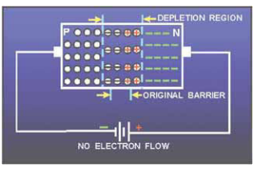

With reverse bias to the junction, a high resistance path is established and hence no current flow occurs. On the other hand, with forward bias to the junction, a low resistance path is set up and hence current flows in the circuit.

**Current Flow in a Forward Biased pn Junction:**

Fig. 5.23 shows a forward biased pn junction. Under the influence of forward voltage, the free electrons in n-type move towards the junction, leaving behind positively charged atoms(negative terminal of battery is connected to n-type. It repels the free electrons in n-type towards the junction). However, more electrons arrive from the negative battery terminal and enter the n-region to take up their places. As the free electrons reach the junction, they become valence electrons(A hole is in the co-valent bond. When a free electron combines with a hole, it becomes a valence electron). As valence electrons, they move through the holes in the p-region. The valence electrons move towards left in the p-region which is equivalent to the holes moving to right. When the valence electrons reach the left end of the crystal, they flow into the positive terminal of the battery.

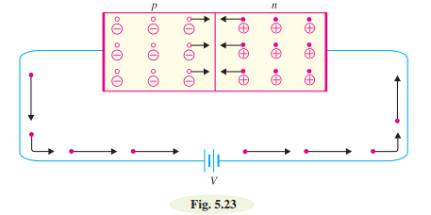

In n-type region, current is carried by free electrons whereas in p-type region, it is carried by holes. However, in the external connecting wires, the current is carried by free electrons.

**Volt-Ampere Characteristics of pn Junction:**

Volt-ampere or V-I characteristic of a pn junction (also called a crystal or semiconductor diode) is the curve between voltage across the junction and the circuit current. Usually, voltage is taken along xaxis and current along y-axis. Fig. 5.24 shows the circuit arrangement for determining the V-I characteristics of a pn junction. The characteristics can be studied under three heads, namely; zero external voltage, forward bias and reverse bias.

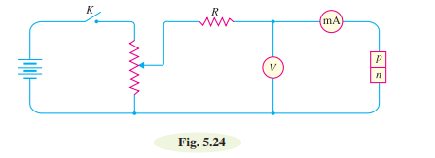

(**i) Zero external voltage**: When the external voltage is zero, i.e. circuit is open at K, the potential barrier at the junction does not permit current flow. Therefore, the circuit current is zero as indicated by point O in Fig. 5.25.

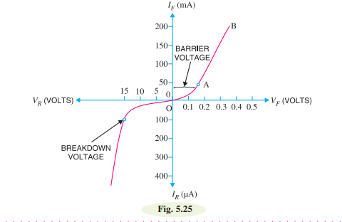

**(ii) Forward bias**: With forward bias to the pn junction i.e. p-type connected to positive terminal and n-type connected to negative terminal, the potential barrier is reduced. At some forward voltage (0.7 V for Si and 0.3 V for Ge), the potential barrier is altogether eliminated and current starts flowing in the circuit. From now onwards, the current increases with the increase in forward voltage. Thus, a rising curve OB is obtained with forward bias as shown in Fig. 5.25. From the forward characteristic, it is seen that at first (region OA),the current increases very slowly and the curve is non-linear. It is because the external applied voltage is used up in overcoming the potential barrier. However, once the external voltage exceeds the potential barrier voltage, the pn junction behaves like an ordinary conductor. Therefore, the current rises very sharply with increase in external voltage (region AB on the curve). The curve is almost linear.

**(iii) Reverse bias**: With reverse bias to the pn junction i.e. p-type connected to negative terminal and n-type connected to positive terminal, potential barrier at the junction is increased. Therefore, the junction resistance becomes very high and practically no current flows through the circuit. However, in practice, a very small current (of the order of µA) flows in the circuit with reverse bias as shown in the reverse characteristic. This is called reverse saturation current (I s ) and is due to the minority carriers. It may be recalled that there are a few free electrons in p-type material and a few holes in n-type material. These undesirable free electrons in p-type and holes in n-type are called minority carriers. As shown in Fig. 5.26, to these minority carriers, the applied reverse bias appears as forward bias. Therefore, a small current flows in the reverse direction.

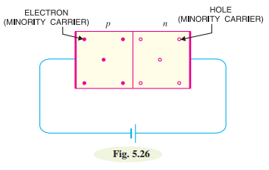

If reverse voltage is increased continuously, the kinetic energy of electrons (minority carriers) may become high enough to knock out electrons from the semiconductor atoms. At this stage breakdown of the junction occurs, characterised by a sudden rise of reverse current and a sudden fall of the resistance of barrier region. This may destroy the junction permanently.

**Static & dynamic resistances:**

The two types of resistance takes place in the p-n junction are:

* Forward resistance
* Reverse resistance

**Forward resistance**

Forward resistance is a resistance offered by the p-n junction diode when it is forward biased.In a forward biased p-n junction diode, two type of resistance takes place based on the voltage applied.

* Static resistance or DC resistance
* Dynamic resistance or AC resistance

**Static resistance or DC resistance**

When forward biased voltage is applied to a diode that is connected to a DC circuit, a DC or direct current flows through the diode. Direct current or electric current is nothing but the flow of charge carriers (free electrons or holes) through a conductor. In DC circuit, the charge carriers flow steadily in single direction or forward direction.

The resistance offered by a p-n junction diode when it is connected to a DC circuit is called static resistance.Static resistance is also defined as the ratio of DC voltage applied across diode to the DC current or direct current flowing through the diode.The resistance offered by the p-n junction diode under forward biased condition is denoted as Rf.

The resistance offered by the p-n junction diode under forward biased condition is denoted by Rf.

**Dynamic resistance or AC resistance**

The dynamic resistance is the resistance offered by the p-n junction diode when AC voltage is applied. When forward biased voltage is applied to a diode that is connected to AC circuit, an AC or alternating current flows though the diode. In AC circuit, charge carriers or electric current does not flow in single direction. It flows in both forward and reverse direction.

Dynamic resistance is also defined as the ratio of change in voltage to the change in current. It is denoted as rf.

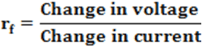

An equation describes the exact current through a diode, given the voltage dropped across the junction, the temperature of the junction, and several physical constants. It is commonly known as the diode equation:

ID = Is {exp. (eVD/kBT) -1},

where ID is diode current in amps and

Is is total saturation current in amps.

VD = Voltage applied across diode in Volts. It is positive for forward bias and negative for reverse bias.

kB = Boltzmann's constant (1.38 х10-33 J/K)

T = Junction temperature in Kelvin

When forward bias is applied, exp. (eVD/kBT) >>1, then ID = Is exp(eVD/kBT)

This shows that in forward bias, current increases exponentially as shown (V-I) graph in figure 3.

When a reverse bias is applied such that exp. (-eVD/kBT) << 1, then ID = -Is

This shows that in reverse bias current remains constant at Is as shown (V-I) graph in figure-3.

**Breakdown phenomena- avalanche and Zener processes:**

**Breakdown voltage**: It is the minimum reverse voltage at which pn junction breaks down with sudden rise in reverse current.

**Avalanche breakdown**

Avalanche breakdown occurs in moderately and lightly doped pn junctions with a wide depletion region. Under normal reverse voltage, a very little reverse current flow through a pn junction. However, if the reverse voltage attains a high value, the junction may break down with sudden rise in reverse current. For understanding this point, refer to Fig. 5.27. Even at room temperature, some hole-electron pairs (minority carriers) are produced in the depletion layer as shown in Fig. 5.27 (i). With reverse bias, the electrons move towards the positive terminal of supply. At large reverse voltage, these electrons acquire high enough velocities to dislodge valence electrons from semiconductor atoms as shown in Fig. 5.27 (ii). The newly liberated electrons in turn free other valence electrons. This process is called impact ionization and leads to production of a large number of electrons. In this way, we get an **avalanche of free electrons**. Therefore, the pn junction conducts a very large reverse current. Once the breakdown voltage is reached, the high reverse current may damage the junction. Therefore, care should be taken that reverse voltage across a pn junction is always less than the breakdown voltage.

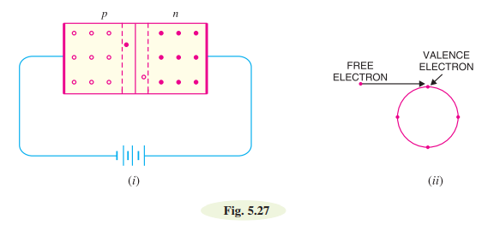

**Zener breakdown**

With increase in doping concentration the breakdown mechanism, changes from Avalanche to a tunnelling mechanism. This is called a Zener breakdown. This is because the depletion width decreases with dopant concentration. This tunnelling process is shown schematically in figure 4, where electrons tunnel from the p side to the n side, driven by the externally applied reverse bias. Tunnelling also leads to a large increase in current.

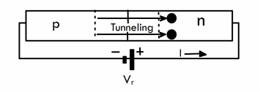

**Zener Diode:**

A properly doped crystal diode which has a sharp breakdown voltage is known as a zener diode.

Fig. 6.53 shows the symbol of a zener diode. It may be seen that it is just like an ordinary diode except that the bar is turned into z-shape. The following points may be noted about the zener diode:

(i) A zener diode is like an ordinary diode except that it is properly doped so as to have a sharp breakdown voltage.

(ii) A zener diode is always reverse connected i.e. it is always reverse biased.

(iii) A zener diode has sharp breakdown voltage, called zener voltage VZ .

(iv) When forward biased, its characteristics are just those of ordinary diode.

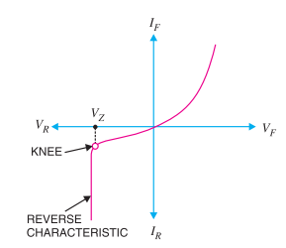(v) The zener diode is not immediately burnt just because it has entered the breakdown region. As long as the external circuit connected to the diode limits the diode current to less than burn out value, the diode will not burn out.

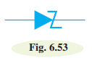

**Equivalent Circuit of Zener Diode:**

The analysis of circuits using zener diodes can be made quite easily by replacing the zener diode by its equivalent circuit.

**(i) “On” state**: When reverse voltage across a zener diode is equal to or more than break down voltage VZ , the current increases very sharply. In this region, the curve is almost vertical. It means that voltage across zener diode is constant at VZ even though the current through it changes. Therefore, in the breakdown region, an ideal zener diode can be represented by a battery of voltage VZ as shown in Fig. 6.54 (ii). Under such conditions, the zener diode is said to be in the “ON” state.

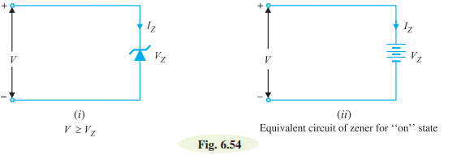

**(ii) “OFF” state**: When the reverse voltage across the zener diode is less than VZ but greater than 0 V, the zener diode is in the “OFF” state. Under such conditions, the zener diode can be represented by an open-circuit as shown in Fig. 6.55 (ii).

